**System Response by Different Inputs in MATLAB and**

**Simulink**

**Lab#02**



**Control Systems Lab**

CSE-310L

**Submitted by:**

Maaz Habib

**Registration Number:**

20PWCSE1952

**Section:**

C

**Submitted to:**

Dr. Muniba Ishfaq

Jan 31st, 2024

**Department of Computer Systems Engineering University of Engineering and Technology, Peshawar**

# TASK# 1

Find an impulse and step response of the following system by using Matlab. Use simulink to find both responses and compare them with Matlab results.

G(s)=10/s2+2s+20

## MATLAB

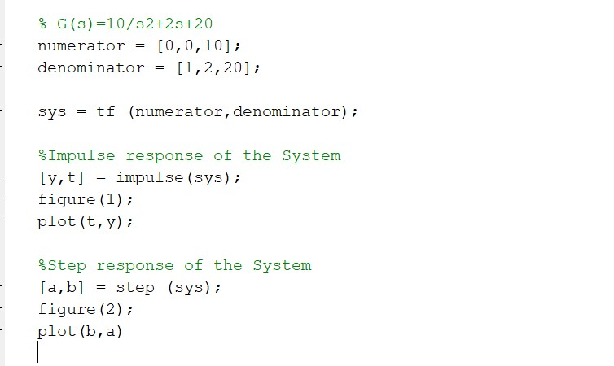

**Step**

**Response:**

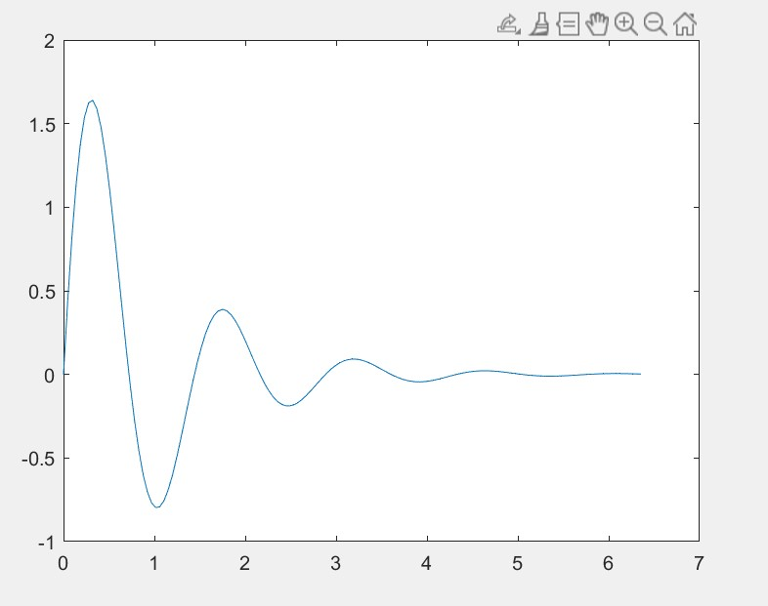

s

**Impulse Response:**

**Simulink**

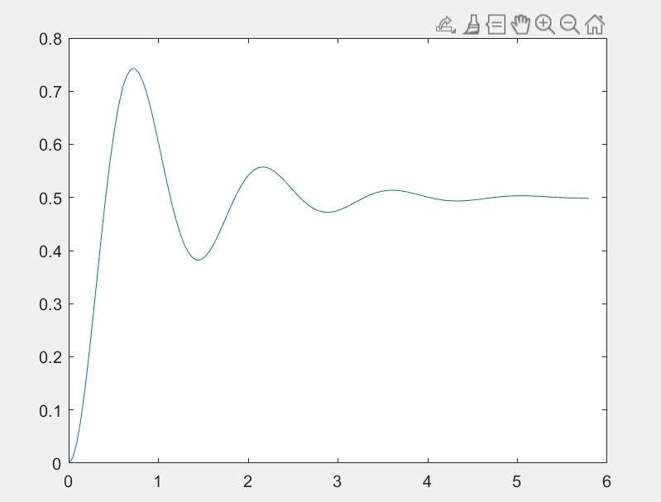

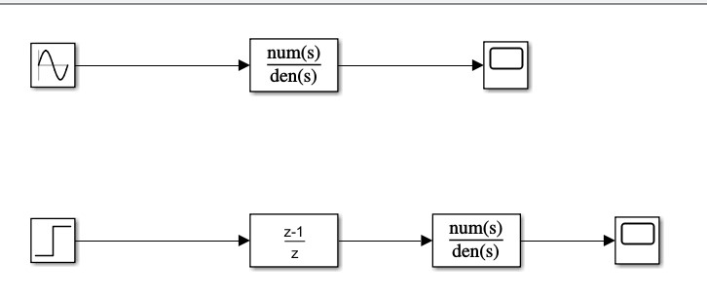

**Step Response**

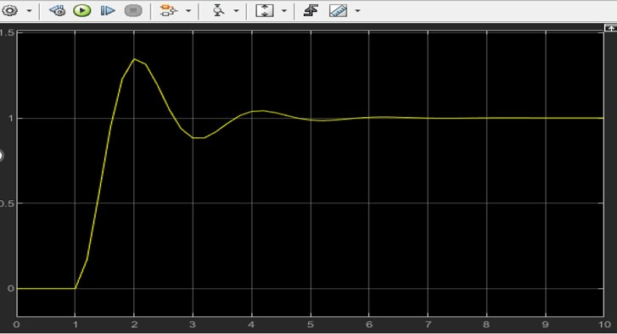

**Impulse Response**

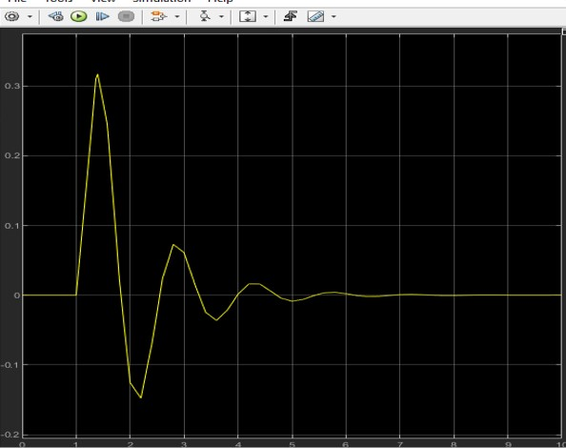

# TASK 2

Also apply the sinusoidal input to the above mentioned system in both Matlab and Simulink. Compare both the results too. Also plot output vs. input in both.

**CODE:**

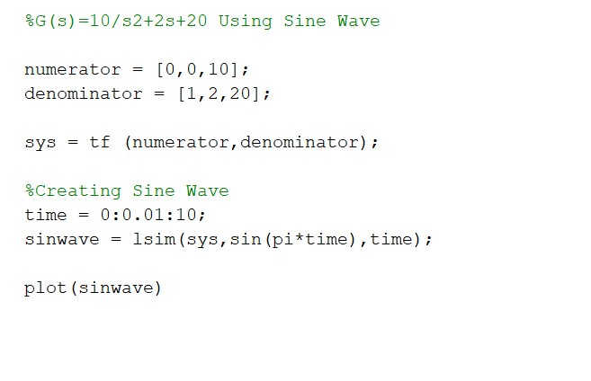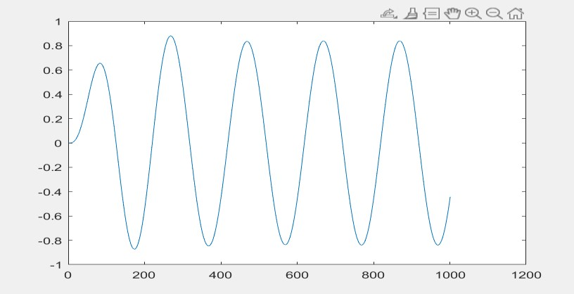

## Simulink

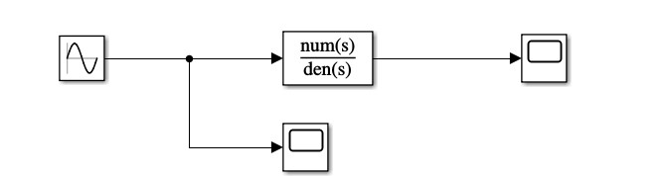

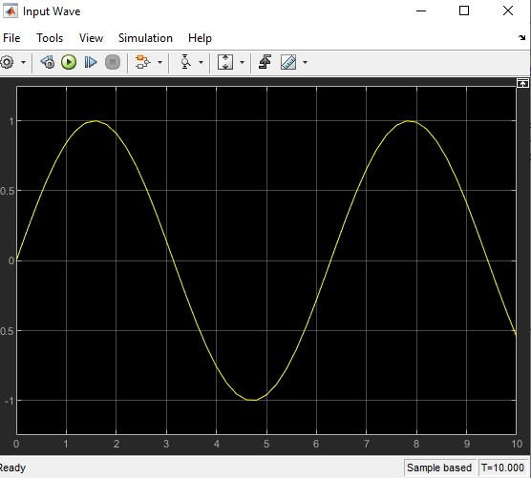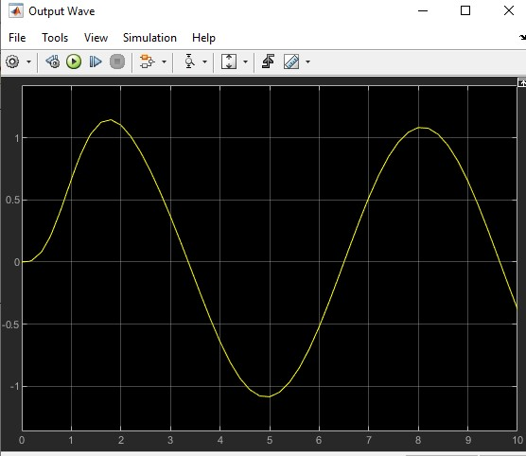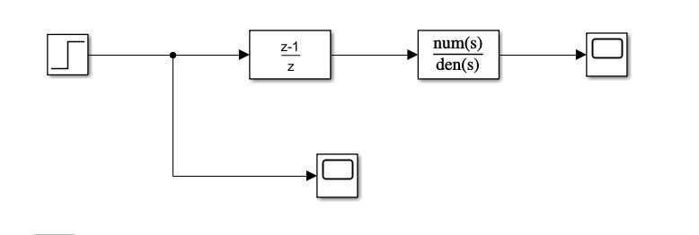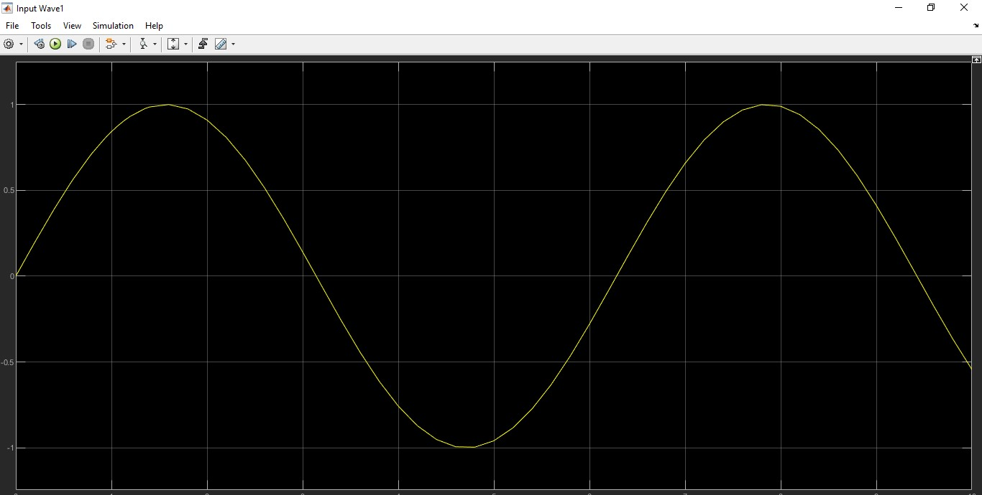

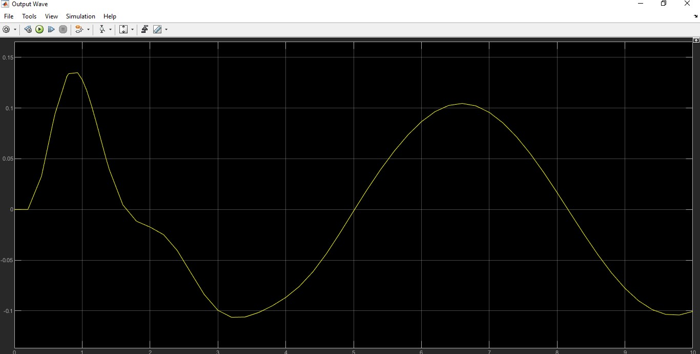

# TASK 3

Apply the following input to the system in both Simulink and Matlab.

sin(2πt) + u(t) + 2u(t-5)

**CODE:**

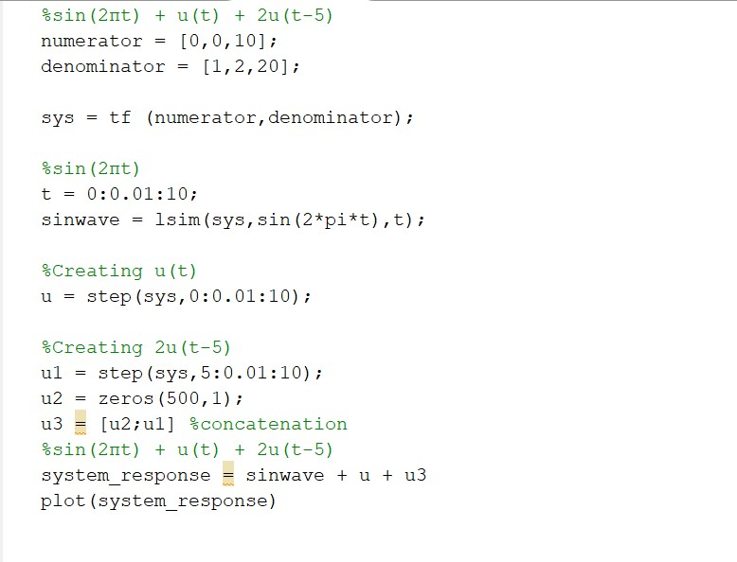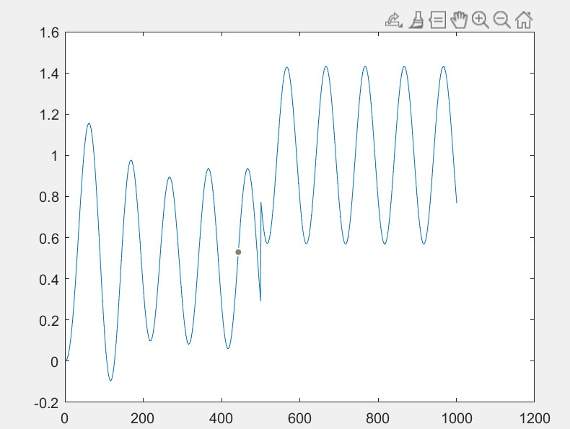

## Simulink

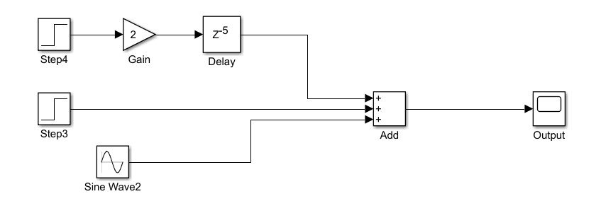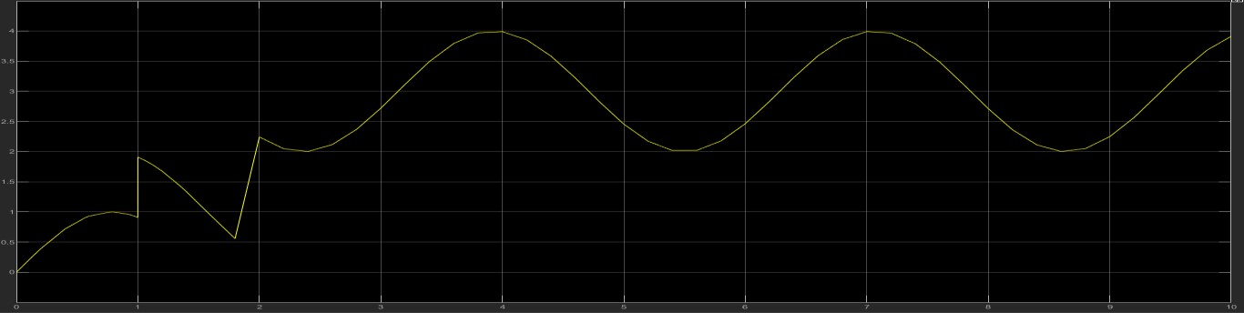

# TASK 4

Square input with amplitude equal to 1 and time period equal to 10 seconds. Simulate the system for at least 40 seconds.

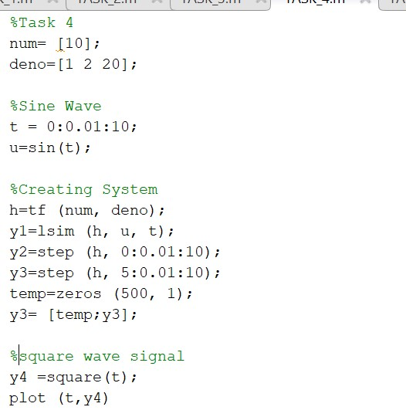

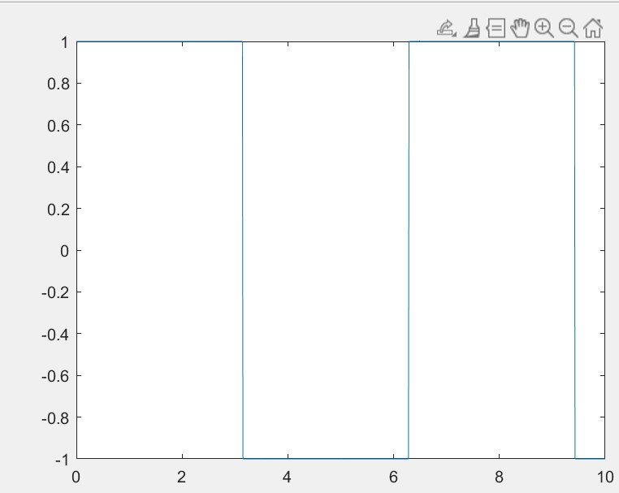

## Simulink

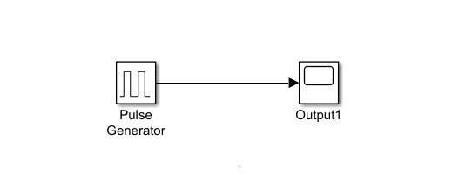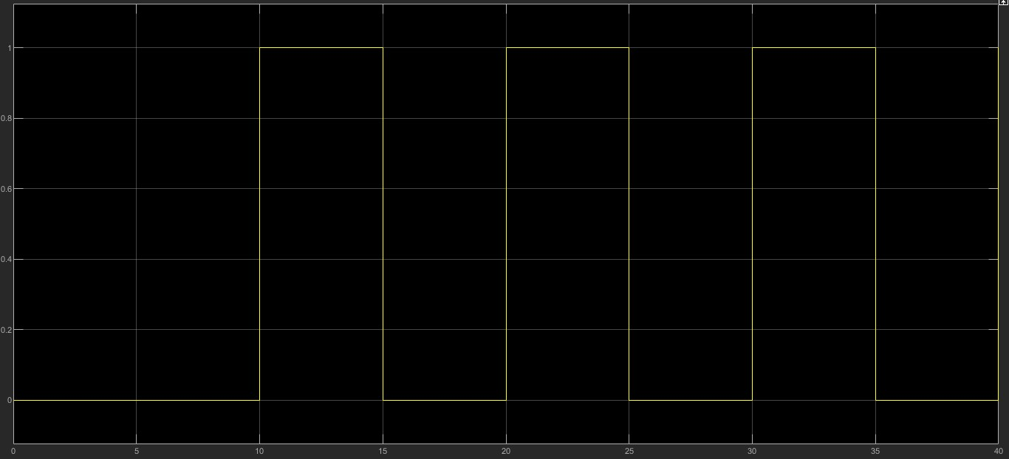

# TASK5

Combine both of the inputs of Q3 and Q4.

## CODE:

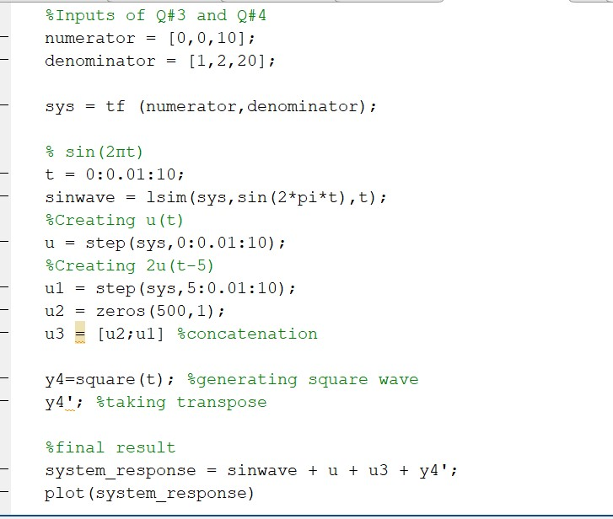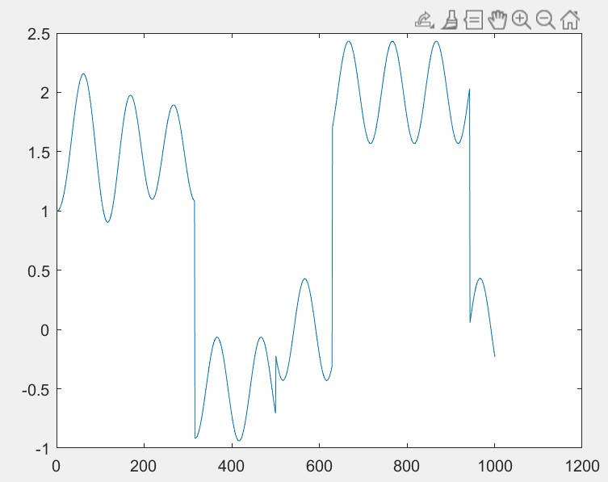

## Simulink

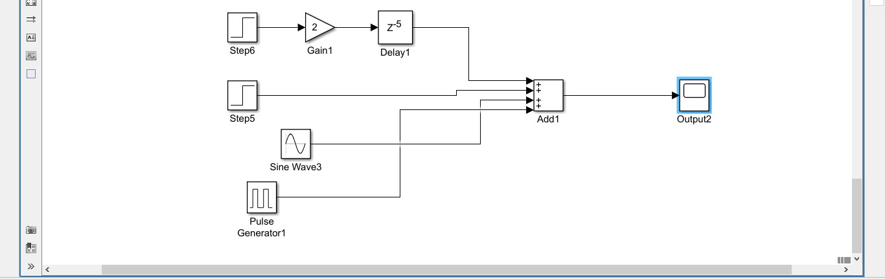

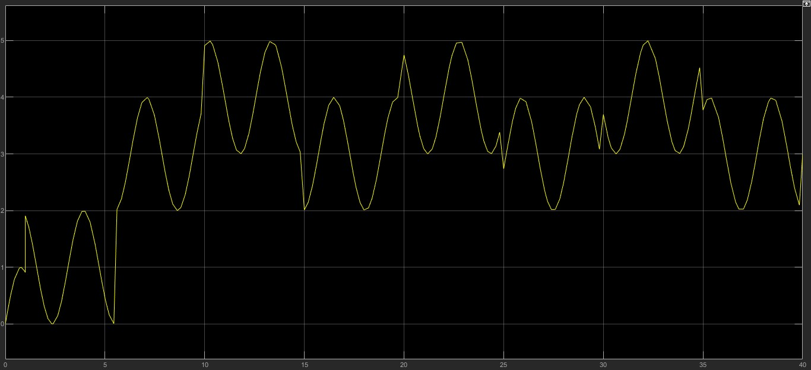

**Conclusion:**

In this task the output waves in both were a bit different, whereas the inputs were almost same.